Alberta Weekly Newspapers Association
'

Notice of Annual Meeting

Notice is hereby given that the Annual Meeting of the Alberta Weekly Newspapers Association (hereinafter called the “Association”) will be held Online on the First day of October, AD, 2020 at the hour of 1:30 pm for the following purposes:

  - to receive the committee reports of the Association;

  - to receive the annual, audited financial statement of the Association setting out its income, disbursements, assets and liabilities;
  - to elect a Board of Directors for 2020/ 2021;

  - to transact such further and other business as may properly come before the meeting or any adjournment or adjournments thereof.

BY ORDER OF THE BOARD
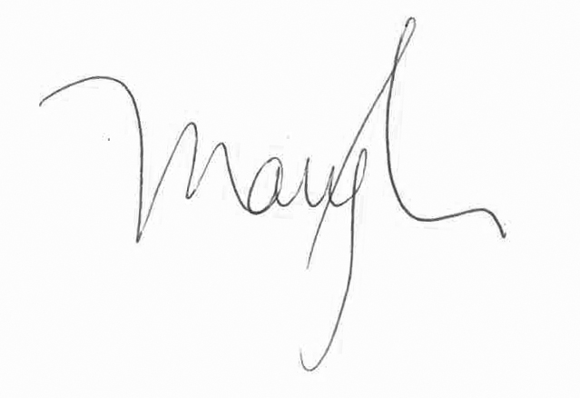

Mary Kemmis
Corporate Secretary

PROXY

Annual Meeting of the
Alberta Weekly Newspapers Association To be held on Thursday, October 1, 2020
The undersigned member of the Alberta Weekly Newspapers Association hereby appoints
of the

as the nominee of the undersigned member to attend and act for the undersigned and on behalf of the undersigned at the Annual Meeting of the Alberta Weekly Newspapers Association which is to be held online on the First day of October, 2020 at the hour of 1:30 o'clock in the afternoon (and at any adjournment or adjournments thereof in the same manner, to the same extent and with the same power as if the undersigned were present at the said meeting or any adjournment or adjournments thereof):
Restrictions on Proxy

(in here the proxy can state any restrictions on the power of the proxy holder)

DATED the day of ,A.D.,2020

Signature of Member

Name of Newspaper

Witnessed by:

