
News release

50 years of growing Alberta’s Ag talent
October 31, 2025 Media inquiries
For 50 years, the Green Certificate Program has helped thousands of students gain hands-on skills and launch successful careers in agriculture.
Established in 1975 as the first program of its kind in Canada, Alberta’s government announced the training program for the province’s future farmers. Alberta is celebrating 50 successful years of this popular rural employment and training program, supporting high school students to enter and build careers in agriculture while earning high school credits at the same time.
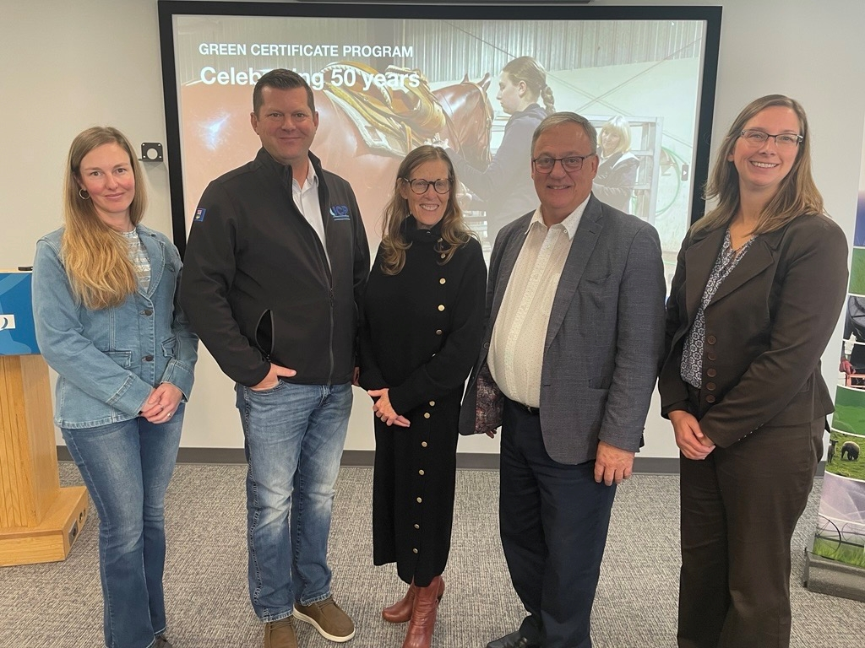
Jessi Selte, Minister Sigurdson, Dr. Wainright, MLA Roswell and Jennifer Stoby celebrate 50 years of Alberta’s Green Certificate Program
Through the program, students develop the confidence, skills and knowledge they need to undertake careers in the agriculture industry. It provides real-life experience for trainees who want to apply for higher education in agriculture and grow their ag employability.
“Since the start of the Green Certificate Program, thousands of students have graduated with the skills and training they need to start a career in agriculture. The program empowers trainees to learn at their own pace, giving them hands-on experience of working for a local farm or agri-business. It continues to support ag employment in our rural communities, sparks new ideas and engages the next generation in the constantly changing world of agriculture.”
RJ Sigurdson, Minister of Agriculture and Irrigation
Government partners with the agriculture industry and four Alberta regional colleges to deliver this valuable training program: Northwest Polytechnic, Lakeland College, Olds College and Lethbridge Polytechnic.
“Lakeland College values the half-century of our involvement with the Green Certificate Program. We’re a great fit as Lakeland and Green Certificate are both about hands-on learning. We’ve benefited as much as the farmers, ranchers, trainees and high school students from the program. We’ve gained instructors and students from our connection to it. We’ve also seen generations of family be connected as trainees, testers, students and two regional coordinators.”
Dr. Alice Wainwright-Stewart, president and CEO, Lakeland College
“The Green Certificate program is a unique learning opportunity. I see strong connections made between students, trainers and testers where students are able to network and dive deeper into the industry. As a coordinator, I have seen all types of students shine in the program. Many have gone on to post-secondary agriculture education and careers. This program has withstood the test of time, and every year it continues to give youth a chance to learn in a very key industry.”
Jennifer Stoby, Green Certificate regional coordinator, Lakeland College
There are 11 primary agriculture industry career options for trainees to choose from. Trainees prepare for jobs by mastering skills working under the guidance of a qualified industry expert. Once the training is complete, students receive 16 high school credits and have the skills to work in an ag occupation of their choosing.
“The Green Certificate course was a unique opportunity to earn high school credits while caring for my sheep. I was also able to expand my knowledge and understand the “why” behind decisions on the farm, especially when it came to animal care. One of my favourite parts was the testing model. The tests felt like a conversation, almost like I was teaching someone what I had learned through the course. This definitely helped my speaking skills and future interview skills. It was a fun and hands-on way to share what I had learned.”
Kaylie Lawrence, instructor, Lakeland College
“Green Certificate is a unique hands-on learning experience that uses student initiative to create very employable and well-informed individuals. Students use this experience to grow the industry in the best ways. Some of them go on to build agri-businesses or become investors while many of them take over their family farms and ranches.”
Jessi Selte, Green Certificate regional coordinator, Lakeland College
Alberta’s government congratulates all past and present participants, instructors and industry partners who have contributed to 50 years of success in agricultural education.

Quick facts
- Green Certificate programming is provided free to students in more than 253 high schools in 333 communities across the province.
- Every year, about 450 Alberta high school students graduate with a Green Certificate credential in a primary ag specialty of their choice.
- In the last 10 years, about 5,000 students have graduated from the program.
- Students learn on the job under the direction of experienced farm personnel with supervision from Green Certificate coordinators.
- The program was started by Walter McNally and grew under the leadership and drive of Green Certificate pioneers Walter Scott and Doug Taylor.
- Available courses include:
  - beekeeper production
  - cow-calf beef production
  - dairy production
  - equine
  - feedlot beef production
  - field crop production
  - greenhouse
  - irrigated field crop production
  - poultry production
    - broiler chicken
    - broiler hatching egg
    - table egg
    - turkey
  - sheep production
  - swine production

Related information
- Green Certificate Program

Multimedia
- Video: Green Certificate Program testing at Lakeland College

Media inquiries

Callum Reid
780-691-7317
Press Secretary, Agriculture and Irrigation

