
News release

Growing production at Alberta’s biggest greenhouse
September 02, 2025 Media inquiries
$2.2 million delivered through Emissions Reduction Alberta will help install new technology to save millions of dollars on energy bills and produce more food for Albertans.
These dollars help Big Marble Farms install cutting-edge horticultural grow lights that will produce more tomatoes and cucumbers using less energy and at a lower cost.
With this funding, more than 5,000 horticultural grow lights will be installed at the Cypress County greenhouse to save almost $2 million in utility costs and produce 4,600 fewer tonnes of emissions. Staff will also receive technical training in ways to reduce energy use.
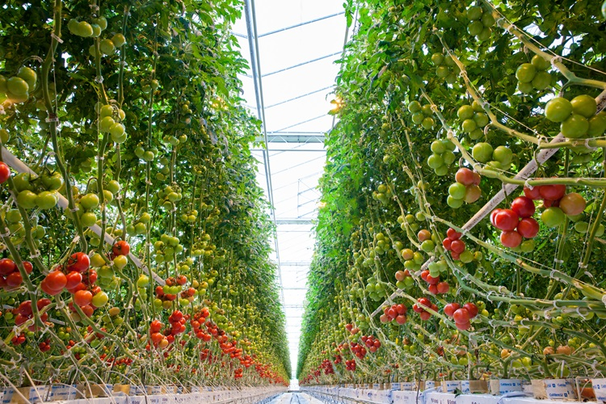
Rows of tomatoes at the Big Marble Farms greenhouse
Alberta’s farmers, ranchers and food industry continue to embrace innovation to feed ever-growing local, national and global demand. The province is seen as a world leader in both emissions reductions and food production.
“Alberta’s food industry is looking for ways to reduce costs, save energy and deliver even more fresh, locally grown produce all year long. These new lights will save millions of dollars while helping a local, family-run success story lower operating costs and build a more productive, reliable local food supply at the same time.”
Rebecca Schulz, Minister of Environment and Protected Areas
“Alberta’s farmers and food processors are leaders in finding new ways to grow more with less. By supporting projects like this, we’re helping greenhouse operators cut energy costs, stay competitive, and deliver fresh, local produce to families year-round. This grant to Big Marble will create new jobs and business opportunities while also putting more locally grown food on Canadian tables. I am confident that we will see more greenhouses choosing Alberta as their base of operations in the future.”
RJ Sigurdson, Minister of Agriculture and Irrigation
“It’s great to see a local family-run business like Big Marble Farms helping move Alberta’s agriculture forward. This funding will strengthen our local food supply while showing the world-class advancements Alberta is making that benefit farmers, families and our community. This is the type of project that creates jobs, fosters growth and drives innovation here in southeastern Alberta.”
Justin Wright, MLA for Cypress-Medicine Hat
High energy costs and outdated technology put strain on greenhouse operators, making it harder to provide fresh, local produce in every season. Funding for Big Marble Farms’ lighting upgrades is delivered through the Strategic Energy Management for Industry Program, which helps Alberta’s industrial and manufacturing facilities increase profitability by reducing energy costs, growing organizational skills and funding the costs of capital retrofits.
“This investment shows how technology strengthens both our economy and our communities. By helping Big Marble Farms cut costs, lower emissions, and increase food production, we’re supporting Alberta’s agriculture sector to stay competitive while ensuring more fresh, local produce for Albertans year-round. It’s a win on every front.”
Justin Riemer, chief executive officer, Emissions Reduction Alberta
The horticultural grow lights will provide the greenhouse with up to 45 per cent more light than its current system, producing bigger crops without higher energy bills. This will help Big Marble Farms save money, stay competitive and continue supplying Albertans with healthy, homegrown produce.
“This grant allows Big Marble Farms to reduce its environmental footprint while strengthening year-round food security for Albertans and western Canadians. By embracing sustainable technology, we’re investing in a future where locally grown produce remains resilient, reliable and available for every table across western Canada. This investment will drive efficiency, sustainability and stronger yields across Big Marble Farms. This step ensures we can continue growing more with less, securing a brighter future for our farm, our people and the communities we serve.”
Ryan Cramer, chief executive officer, Big Marble Farms

Quick facts
- Big Marble Farms is currently home to more than 496,000 cucumber plants, 385,000 tomato plants and 47,000 grow lights.
- The Strategic Energy Management for Industry program is funded by the Government of Alberta and Natural Resources Canada.
  - The program covers up to 50 per cent of eligible project costs for for-profit organizations and up to 100 per cent of eligible project costs for not-for-profits and Indigenous organizations.
  - The program is designed to help Alberta’s mining, forestry and agriculture, oil and gas, utilities, construction, manufacturing, transportation, waste management and other sectors save money by reducing operating and maintenance costs, increase competitiveness and lower emissions through technology and innovation.
  - Applications are open until March 2027.

Related information
- Emissions Reduction Alberta’s Strategic Energy Management for Industry Program
- Technology Innovation and Emissions Reduction System
- Big Marble Farms

Media inquiries

Ryan Fournier
780-232-2213
Press Secretary, Environment and Protected Areas

