
News release

Have your say on South Athabasca land use
December 17, 2025 Media inquiries
Albertans can share ideas on how the South Athabasca area is used for work, recreation, conservation and much more.
Albertans are invited to give feedback on the draft South Athabasca Sub-Regional Plan and regulations that will direct how land is used in this diverse part of north-eastern Alberta.
The South Athabasca area covers more than 38,800 kilometres and supports many industries, including energy, forestry, agriculture, tourism and recreation, as well as Indigenous Treaty rights and traditional land uses.
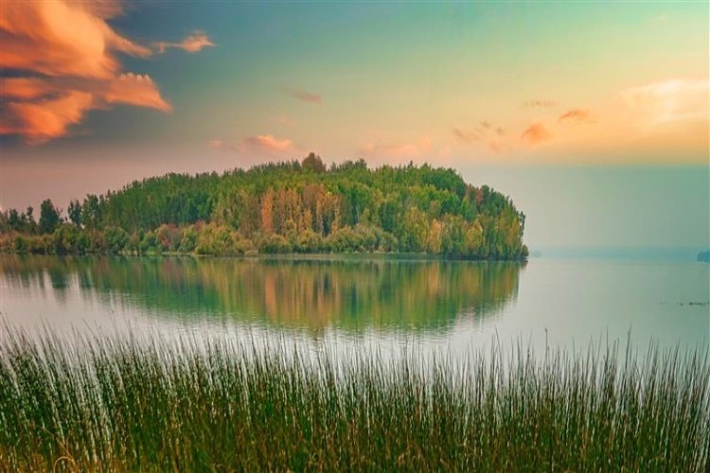
An area outside of Lac La Biche, in the South Athabasca sub-region
“South Athabasca is one of Alberta’s most stunning and hard-working landscapes. We want to hear from anyone who lives, works or plays here so we can finalize a plan that creates jobs, supports rural and indigenous communities and strengthens sustainable conservation.”
Rebecca Schulz, Minister of Environment and Protected Areas
The draft sub-regional plan, along with associated regulatory details, is based on discussions with Indigenous communities, local governments, industry and others. It identifies conservation areas, supports caribou habitat restoration, and outlines potential direction for activities such as forestry, grazing, recreation and energy development.
The draft plan is not final and is designed to help generate input and detailed feedback. Albertans can review the plan immediately and give input starting Jan. 9.
All feedback will be closely reviewed. It will be used to help finalize the plan and, ultimately, support economic growth, conservation and strong communities in the South Athabasca sub-region.
Alberta’s government will continue working with Indigenous communities and organizations, local governments, industry and others as the South Athabasca Sub-Regional Plan is finalized and then implemented.

Quick facts
- The South Athabasca sub-region is located south of Fort McMurray and encompasses the communities of Lac La Biche and Cold Lake and overlaps Treaty 6, Treaty 8 and Treaty 10 lands.
- Public engagement opens on Jan. 9 and runs until April 9.
- The sub-region is bordered on the north and west by the Clearwater and Athabasca Rivers, to the south by the Beaver River, and by the Saskatchewan border to the east. Large portions of the area are occupied by the Cold Lake Air Weapons Range and the Gipsy-Gordon and Dillon River Wildland Provincial Parks.
- The South Athabasca Sub-Regional Plan will replace the existing Cold Lake Sub-Regional Plan and regulatory details.
- This engagement fulfills the requirements in the Alberta Land Stewardship Act for amendments to the Lower Athabasca Regional Plan.
- Sub-regional plans help support economic growth of the area while improving the overall landscape condition, so the land is better able to support local recreation, caribou recovery and the sustained practice of Indigenous Treaty rights and traditional land uses.

Related information
- South Athabasca Sub-regional Plan engagement

Media inquiries

Ryan Fournier
780-232-2213
Press Secretary, Environment and Protected Areas

