Modernizing Alberta’s Animal Protection Act
March 30, 2026 Media inquiries
Proposed amendments will make Alberta a leader in animal protection.
Alberta’s government is updating the Animal Protection Act for the first time in 20 years. Bill 22, the Animal Protection Amendment Act, will see changes designed to improve animal welfare in our province.
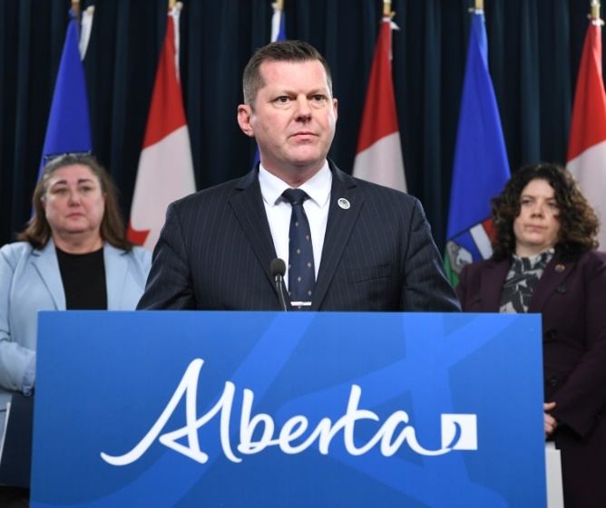
Leanne Niblock, executive director, Alberta Society for the Prevention of Cruelty to Animals, RJ Sigurdson, Minister of Agriculture and Irrigation, and Megan Bergman, registrar, Alberta Veterinary Medical Association
If passed, the proposed amendments would modernize terms and definitions and align the act with other Canadian jurisdictions.
Proposed changes would give peace officers better tools to protect animals from distress and ensure compliance with the legislation. The amendments also expand the types of locations and businesses that can be inspected to include boarding and grooming facilities. This will ensure peace officers can assess animals in more places where they are present.
The changes also strengthen penalties for offenders under the act, increasing maximum fines from $20,000 to $250,000 and introducing potential jail terms, up to 12 months, for serious offences.
The amendments would make Alberta a leader in addressing repeat offences. The act improves when and how court orders are issued and how they are enforced. Alberta would also become the first province to enable the enforcement of orders issued in other provinces and territories, helping to ensure that that people with a demonstrated inability to provide appropriate animal care do not reoffend in Alberta.
“Bill 22 is an important step for Alberta, underscoring the province’s commitment to animal welfare. Beyond updating the legislation, it sends a clear message that protecting animals is a top priority. Alberta is dedicated to ensuring all animals are treated with respect and protected by these safeguards.”
RJ Sigurdson, Minister of Agriculture and Irrigation
The proposed amendments were informed by feedback from engagement sessions with key stakeholders including animal protection agencies, livestock organizations and veterinarians.
“We’re thrilled the Government of Alberta is demonstrating its commitment to animal welfare by reviewing the Animal Protection Act. The proposed updates will strengthen tools for our peace officers, better protect animals and reinforce Alberta’s leadership in animal welfare.”
Leanne Niblock, executive director, Alberta Society for the Prevention of Cruelty to Animals
“Providing leadership in animal health and welfare is a core objective of the ABVMA, and the proposed changes to the Animal Protection Act support that objective. Alberta veterinarians and technologists have a shared mission to uphold a competent and ethical profession while advancing quality veterinary care in the province. These changes represent an important step toward ensuring we have the tools needed to support appropriate care for animals across the province. The Alberta Veterinary Medical Association looks forward to continuing to engage with the Government of Alberta on this important work.”
Megan Bergman, registrar, Alberta Veterinary Medical Association
Quick facts
- The intent of the Animal Protection Act is to ensure the basic care of all animals and to enable peace officers and police to respond to animals that are abandoned, in distress or lacking care.
- Engagement was completed with targeted organizations in May and June, 2025.
  - Participants included peace officers/enforcement organizations, municipalities, livestock industry representatives, veterinary professionals, humane societies, other government representatives and First Nations.
Multimedia
- Watch the news conference
- Listen to the news conference

Media inquiries
Callum Reid
780-691-7317
Press Secretary, Agriculture and Irrigation

