
News release

Planting trees and creating jobs
June 24, 2025 Media inquiries
Over $55 million is being invested to plant five million new trees, recover caribou habitat and create jobs.
Populations in most of Alberta’s 15 caribou ranges are finally stable or growing. However, caribou’s long-term recovery is still threatened by thousands of kilometres of legacy seismic lines left barren since trees were cleared decades ago. Properly re-foresting these areas is complex and difficult work requiring special expertise from northern Albertans.
Alberta’s government is investing $55.8 million over six years to plant five million trees across northern Alberta by 2030. This funding will help create hundreds of jobs through various tree-planting projects and help Alberta’s treasured woodland caribou increase in numbers.
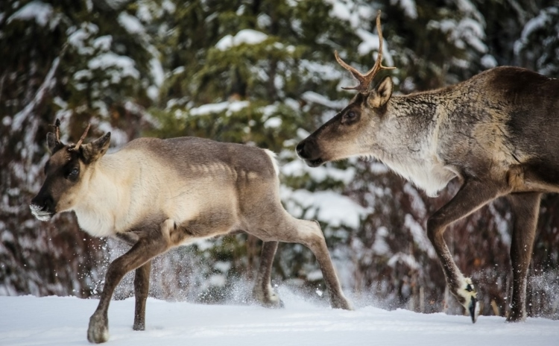
A caribou cow and calf trotting across a snowy landscape in Alberta. (Credit: Government of Alberta)
“These legacy seismic lines are a challenge to threatened wildlife in our forests and have little to no economic benefit to Albertans. These investments will help us create habitats over time by replanting trees while creating jobs for hard-working Albertans, benefitting Alberta’s economy and environment.”
Rebecca Schulz, Minister of Environment and Protected Areas
This new funding commitment is yet another significant Alberta government investment in tree-planting efforts that will help to expand the economy while encouraging caribou recovery. Since 2019, more than 4,500 km of seismic lines have already been assessed and treated in caribou ranges, including 2,400 km in the past 18 months alone.
This funding is part of a partnership with Natural Resources Canada. Alberta Environment and Protected Areas will work with communities and other partners to plant five million new trees across 15 caribou ranges. This increased restoration work will help create jobs for rural and Indigenous communities while supporting Alberta’s long-term caribou recovery efforts.

Quick facts
- Woodland caribou in Alberta are listed as a threatened species.
- Planting trees along legacy seismic lines is not as simple as putting seedlings in the earth.
  - Properly restoring the forests requires extensive planning, heavy equipment and specific expertise.
  - The soil must be prepared in a way that allows good drainage and that lets the right amount of rain and moisture reach the newly planted trees.
- More than $70 million has already been invested in restoring caribou habitat through the Caribou Habitat Recovery Program across the province.
- This funding is part of a partnership with Natural Resources Canada, which will announce its funding contribution in the future.
- Alberta already plants more than one million new trees a year through other provincially funded environmental programs.
- Additional information on tree-planting activities and progress will be shared as the funding is implemented and work unfolds.

Media inquiries

Ryan Fournier
780-232-2213
Press Secretary, Environment and Protected Areas

