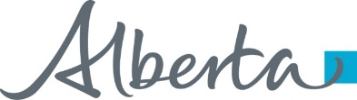**News** release

**Possibilities in the pipe for Nordegg**

July 17, 2025 Media inquiries

Alberta’s government is reducing utility costs and boosting rural economic development by expanding natural gas service to the Nordegg area.

To address the higher heating costs faced by families and businesses in the Nordegg regions – saving them up to 25 per cent on their utility bills – Alberta’s government is providing $2.5 million through the Rural Gas Program to build a natural gas pipeline. This pipeline will provide Nordegg and surrounding communities with safer, more reliable and more affordable heating, as well as more opportunities to grow their local economies.

Albertans living in rural and remote areas face unique challenges in accessing the affordable, reliable utilities they need. In Nordegg, to keep families, homes and businesses warm during cooler weather, residents have relied primarily on propane and other alternative heating fuels, and as a result, face significantly higher utility bills than the average Albertan.

“By delivering natural gas to the Nordegg area, we’re making life more affordable for families and businesses, as well as laying the groundwork to help this beautiful region of our province grow and thrive for many years to come.”

*Nathan Neudorf, Minister of Affordability and Utilities*

“This project is a game-changer for Nordegg and the surrounding area. Reliable, affordable access to natural gas means real savings for families and a boost for the local economy. I’m proud to see this investment in our communities and their prosperity.”

*Jason Nixon, MLA for Rimbey-Rocky Mountain House-Sundre*

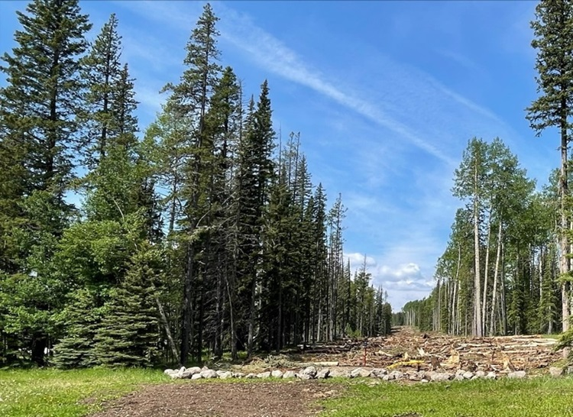

*Nordegg pipeline extension near the Nordegg Ranger Station.*

The 11-kilometre natural gas pipeline will run along Highway 11 into the Village of Nordegg, connecting the community to the nearby Tidewater Stolberg Gas Plant. Construction began in February and is expected to be completed by fall.

“This project is a valuable partnership that will create new opportunities for business, and a brighter, more sustainable future for our rural community.”

*Michelle Swanson, Reeve, Clearwater County*

“The government’s support for the Nordegg Gasification Project is a reminder of the power of partnership in building rural Alberta. It means economic growth, community resilience, and opportunity for generations to come.”

*Tom Kee, Executive Director, Federation of Alberta Gas Co-ops*

To help rural communities across the province access critical services like gas, power and water, $8.5 million is being provided through Budget 2025 for the Rural Utilities Program. This program consists of the Rural Electric Program, Rural Gas Program, Rural Water Program and the Remote Area Heating Allowance, which delivers direct financial relief to thousands of Albertans facing the higher costs of alternative heating fuels where natural gas service is not available.

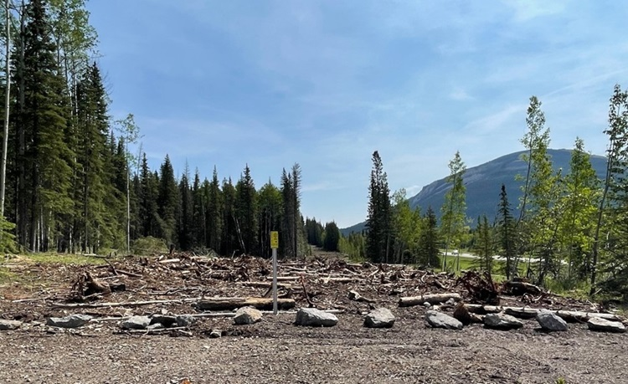

**Quick facts:**

* The Rural Gas Program was established in 1973 and has distributed more than $500 million to help build the largest rural gas distribution system in the world.
* Rural Gas Program funding is administered by the Federation of Alberta Gas Co-ops.

**Related information**

* [Farm fuel and rural utility programs](https://www.alberta.ca/farm-fuel-and-rural-utility-programs)

**Related news**

* [Powering life in rural Alberta](https://www.alberta.ca/release.cfm?xID=93081A994950D-CA28-FCC8-B9FC154E7BBEAAA0) (April 2, 2025)
* [Power up, costs down](https://www.alberta.ca/release.cfm?xID=930310D112E28-FD76-4E40-C64EA7AAF832A4FE) (March 25, 2025)
* [Keeping Albertans’ lights on and homes warm](https://www.alberta.ca/release.cfm?xID=91201DEFE9113-CA6C-F242-0301C3A6F7C494C8) (Oct. 21, 2024)

**Media inquiries**

[**Ashli Barrett**](mailto:ashli.barrett@gov.ab.ca)

587-545-8821  
Press Secretary, Affordability and Utilities