
News release

Protecting Alberta from droughts and floods
October 03, 2025 Media inquiries
Alberta’s government is investing $25 million to help protect people, homes, businesses and communities from floods and droughts.
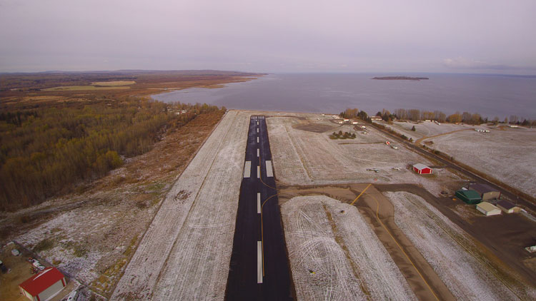
A retaining wall will be built to protect the Slave Lake Airport and Helitack Base during floods.
In recent years, drought and flooding have been felt across the province, and building the critical infrastructure needed to protect Albertans can be costly for many municipalities.
Alberta municipalities and Indigenous communities can now apply for major funding to help protect people, homes and infrastructure from floods and drought.
This fall, $25 million is available for communities across the province as part of the five-year, $125 million Drought and Flood Protection Program.
“We are continuing to step up to help protect communities from the risks of drought and floods for years to come. With another $25 million in funding available this fall, we are supporting communities across our province in building the infrastructure they need.”
Rebecca Schulz, Minister of Environment and Protected Areas
“Drought and floods can threaten public safety and have devastating effects on critical infrastructure, private property and our economy. That’s why we continue to invest in priority projects that protect families from extreme weather events and keep businesses safe and operating for years to come.”
Grant Hunter, Associate Minister of Water
Alberta’s Drought and Flood Protection Program is helping communities make the upgrades they desperately need. To date, $50 million has been invested into 28 projects, including funding to help the Regional Municipality of Wood Buffalo improve its water infrastructure and Siksika Nation build roadways to act as flood berms.
“Rural municipalities manage 85 per cent of Alberta’s land and therefore make significant contributions to Alberta’s flood and drought resiliency. Rural Municipalities of Alberta appreciates the Government of Alberta’s support for local flood and drought mitigation infrastructure investment. The Drought and Flood Protection Program is a key component of protecting rural communities and industry from flood and drought risks.”
Kara Westerlund, president, Rural Municipalities of Alberta
The program has also provided funding to help Medicine Hat protect its wastewater treatment plant from flooding and help Pincher Creek install water intakes within the Crowsnest River and assess future options to help meet water demand, along with many other important projects.
The application deadline for this round of funding is Dec. 1. Municipalities, improvement districts, special areas, Metis Settlements, First Nations and, new this year, regional service commissions and Tribal Councils, are all eligible and encouraged to apply.

Quick facts
- Projects eligible for funding include, but are not limited to:
  - Drought and flood-proofing or relocation of critical infrastructure and infrastructure required to access those services.
  - Structural measures such as berms, flood walls, bank protection and stabilization works, retention ponds and diversion structures intended to protect critical infrastructure and ensure public safety.
  - Purchase of property for the purpose of relocation or for access to and/or construction of a project.
  - Infrastructure designed to increase flood attenuation and reduce the impacts of drought.
- Details on the program and all previously funded projects is available at Alberta.ca.

Related information
- Drought and Flood Protection Program

Related news
- Protecting homes and businesses from drought and floods (Mar. 27, 2025)
- Protecting communities from drought and floods (Aug. 6, 2024)

Media inquiries

Ryan Fournier
780-232-2213
Press Secretary, Environment and Protected Areas

