
News release

Reynolds Museum rolls into the new year with class
January 08, 2026 Media inquiries
Two rare, luxury vehicles are racing to the Reynolds Museum as the newest additions to its classic car collection.
Wetaskiwin is home to the Reynolds Museum, an international award-winning museum dedicated to celebrating machines that shape the unique culture, heritage and history in Alberta and beyond. With the recent donation of a 1930 Packard and 1931 Cadillac, expected to hit the Reynolds showroom in spring 2026, Albertans will be able to explore the unique journey of these classic automobiles.
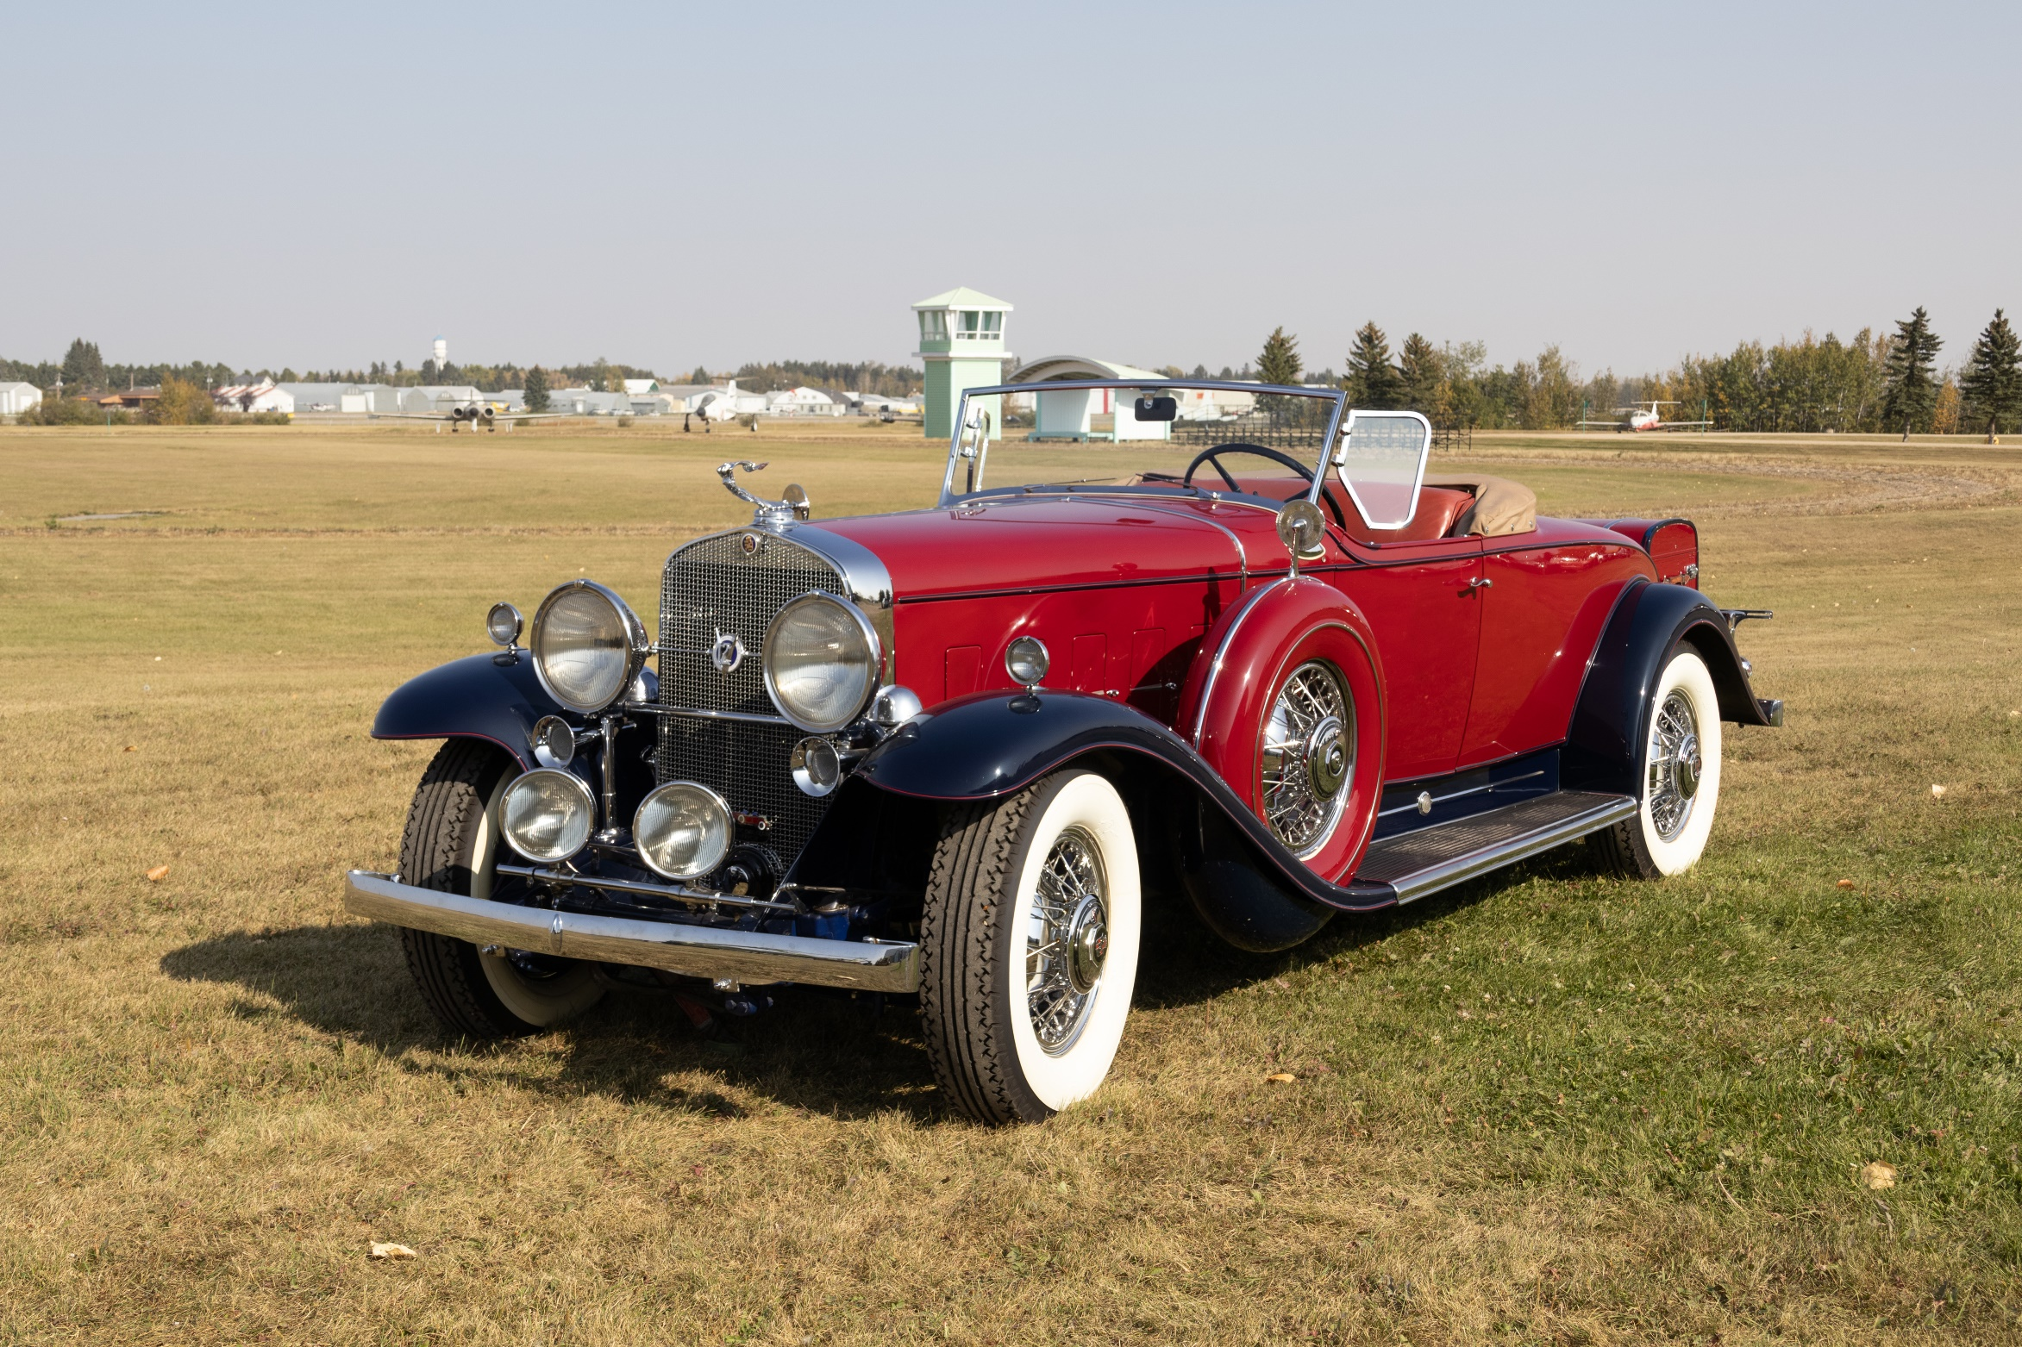
Reynolds Museum's new 1931 Cadillac
“We are proud to bring Alberta’s rich culture and heritage to life at our provincial sites and museums. The donation of these classic vehicles to the Reynolds Museum strengthens our collections and ensures visitors can continue exploring the history that helped shape our province.”
Tanya Fir, Minister of Arts, Culture and Status of Women
The 1930 Packard Standard Eight Phaeton donated was previously owned by prominent Alberta artists Peter and Catharine Whyte. This car exemplifies the refinement and craftsmanship of one of America’s premier luxury automakers at the dawn of the Great Depression.
The donation also includes a rare 1931 Cadillac Model 370A. As the only known Canadian-built V12 roadster in existence today, it stands as a testament to Cadillac’s engineering prowess and to Canada’s brief yet distinguished role in crafting pre-war luxury automobiles.
“The Reynolds Museum keeps working to expand and improve its vast collections through the generous donations of private individuals like the Holker family. The items we accept all have historical significance to Alberta and Canada and will be preserved for generations to come.”
Noel Ratch, director, Reynolds Museum, Alberta Arts, Culture and Status of Women
In 2025, the Ultimate Car Show brought a record 5,400 visitors to the Reynolds Museum in July, its highest attended event to date. With this upcoming showcase, the museum looks forward to providing Albertans with even more opportunities to connect with the stories that celebrate the spirit of machines.

Quick facts
- The Reynolds Museum collects in four mandate areas: transportation, aviation, agriculture and industry.
- The 1930 Packard 733 and 1931 Cadillac 370A V12 are rare, pre-war luxury vehicles.
- The Packard served as Catharine Robb’s wedding car before donation to the Reynolds Museum, and the Cadillac stands as the sole known Canadian-built V12 roadster, restored in the 1980s.
- The museum is expected to display these vehicles at the Great Hall near the main entrance in spring 2026.

Related information
- Reynolds-Alberta Museum
- Photos of the museums' new cars

Related news
- Skyrocketing attendance at Alberta heritage sites (Nov. 10, 2025)

Media inquiries

Juliana Rodriguez
587-338-2302
Press Secretary, Arts, Culture and Status of Women

