# Step into Alberta’s natural beauty on Parks Day

July 18, 2025

Visit an Alberta park on July 19 to celebrate Parks Day with your community.

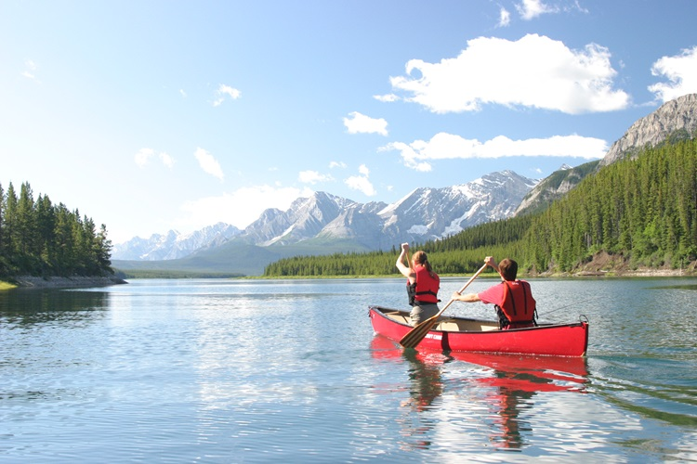

*Two people canoe on a lake during a summer day in Kananaskis Country.*

From mountains to vast prairies, Alberta is home to captivating wild spaces offering countless opportunities to explore, enjoy and reconnect with nature. Whether it’s hiking, fishing, camping or hanging out by the beach, Alberta’s provincial parks and protected areas have an activity for everyone.

Alberta’s parks offer more than beautiful landscapes – they play a key role in boosting physical health and mental well-being and are community spaces that encourage connection to each other and nature. Alberta Parks hosts special Parks Day events across the province, including family friendly activities, as well as educational programs that celebrate Alberta’s wildlife, environment and history.

“I want to wish all Albertans a happy Parks Day! Parks Day gives us the opportunity to celebrate the incredible outdoor spaces that define our province – from the badlands to rugged backcountry trails, to the peaceful lakeside campgrounds. Parks are for people, and whether you are headed out to camp, fish or hike this weekend, Alberta Parks offers something for everyone to celebrate, recreate and enjoy nature.”

*Todd Loewen, Minister of Forestry and Parks*

Since 1990, Parks Day has been celebrated on the third Saturday in July to highlight the benefits of parks and natural spaces across Canada. In 2025, Alberta’s provincial parks system celebrates 95 years of protecting the province’s natural heritage, preserving critical habitats and providing a home to a diverse range of wildlife. Alberta Parks offers many activities for the whole family throughout the year, including guided tours, hikes and educational programs designed to provide fun for all ages.

“Alberta’s provincial parks are where memories are made, families connect, and visitors from near and far come to experience the beauty and spirit of our province. As we celebrate Parks Day and 95 years of Alberta’s parks system, we recognize the vital role these natural spaces play in our well-being, our tourism economy and our connection to the land. TIAA is proud to join Albertans in honouring the places that inspire adventure, reflection, and community.”

*Darren Reeder, president and CEO, Tourism Industry Association of Alberta (TIAA)*

This year, Alberta’s government is engaging the public on the draft Plan for Parks*.*Albertans can participate in the online survey until July 26 to have their say in the future of our parks. Alberta’s government also launched a seniors’ discount on camping fees for Albertans at select campgrounds, opening the door to more low-cost outdoor adventures and opportunities to foster a deeper connection with nature.

## Quick facts

* Alberta’s provincial parks system contains 464 provincial parks and protected areas.
* Alberta recently established Gipsy Gordon Wildland Provincial Park, adding 150,000 hectares to the parks system.
* Last year, 591,000 camper nights were booked at Alberta parks.
* The [*Provincial Parks and Protected Areas Act*](http://www.qp.alberta.ca/574.cfm?page=P35.cfm&leg_type=Acts&isbncln=9780779753840&display=html%29) was passed in 1930 and Alberta’s first park – Aspen Beach Provincial Park – was established in 1932.

## Related information

* [Parks Day events](https://can01.safelinks.protection.outlook.com/?url=https%3A%2F%2Falbertaparks.ca%2Fparksday&data=05%7C02%7CBin.Wu%40gov.ab.ca%7C281350888d044c8ed44308ddc63a1fee%7C2bb51c06af9b42c58bf53c3b7b10850b%7C0%7C0%7C638884675174652358%7CUnknown%7CTWFpbGZsb3d8eyJFbXB0eU1hcGkiOnRydWUsIlYiOiIwLjAuMDAwMCIsIlAiOiJXaW4zMiIsIkFOIjoiTWFpbCIsIldUIjoyfQ%3D%3D%7C0%7C%7C%7C&sdata=jWh2kx8ymhfNVFhjNoCh29FsiVOBWNgYpY4pPQLgX1g%3D&reserved=0)
* [Plan for Parks engagement page](https://www.alberta.ca/plan-for-parks-engagement)