
News release

Super-heavy load affects travel in central Alberta
April 21, 2026 Media inquiries
Drivers may experience delays as a large, slow-moving load will move from Blackfalds to Fort McMurray on April 22.
Due to its large size and weight, this load will travel at a maximum speed of 65 km/h, using the entire width of the highway including the shoulder. The load will move with guide vehicles, traveling below posted speed limits.
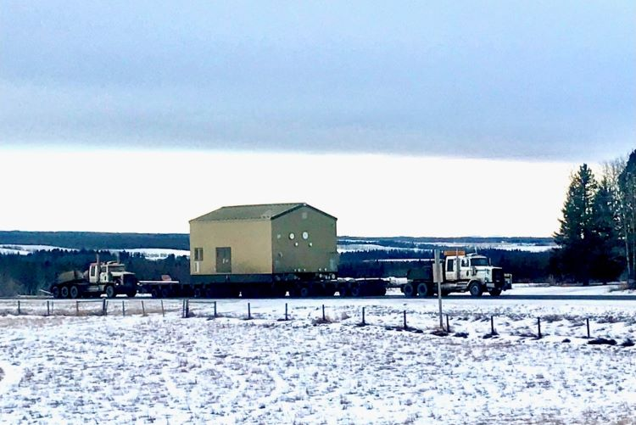
Motor control centre (MCC) building designed to house, protect and centralize electric motor controllers and electrical equipment.

Route
The load will leave WorleyCord in Blackfalds using the following route:

Day 1 April 22 (10 a.m. day move)
- Exit from 5421 Industrial Way, Blackfalds
- Blackfalds Industrial Way southbound
- Highway 597 eastbound
- Highway 815 southbound
- Highway 11 eastbound
- Highway 601 northbound
- Highway 21 northbound
- Highway 14 eastbound
- Highway 834 northbound
- Highway 15 westbound
- Highway 29 eastbound
- Highway 831 northbound
- Highway 28 westbound
- Highway 63 northbound
- Stage at Radway Scale (6 p.m.)

Day 2 April 23 (7 a.m. day move)
- Highway 63 northbound
- Stage at point of entry 35 km south of Fort McMurray (3 p.m.)

Day 3 April 24 (2 a.m. night move)
- Highway 63 northbound
- East Athabasca Highway eastbound
- South into Imperial Oil site (5 a.m.)

Quick facts
- The load being transported is a motor control centre (MCC) building designed to house, protect and centralize electric motor controllers and electrical equipment.
- The building is 7.9 metres wide, 8.2 metres high, and 52 metres long.
- The weight of the unit is 200,700 kilograms, including support equipment.
- The trailers carrying the unit contain 96 wheels.

Road Reports
For up-to-date road information and traffic delays:
- Toll free: 511 (in Alberta)
- Call: 1-855-391-9743 (outside Alberta)
- Visit: 511.alberta.ca
- Download the 511 mobile app
- Follow: @511Alberta

Media inquiries

Husam Khalo
587-346-9153
Press Secretary, Transportation and Economic Corridors

