**News** release

**Sustaining Alberta’s rangelands**

July 29, 2025 Media inquiries

Alberta’s government is investing $1.3 million to strengthen the health, biodiversity and long-term resilience of the province’s rangelands.

Alberta’s rangelands need to be managed with care, and there are many creative ideas to help continue their health into the long term. The Rangeland Sustainability Program supports academics, non-profits and other agricultural partners in turning their innovative ideas into reality.

This year’s Rangeland Sustainability Program grant recipients include academic institutions, Indigenous organizations, non-profits and grazing associations. Funded projects support education and community outreach, adaptive grazing practices, conservation strategies, grassland bird conservation and bee biodiversity surveys.

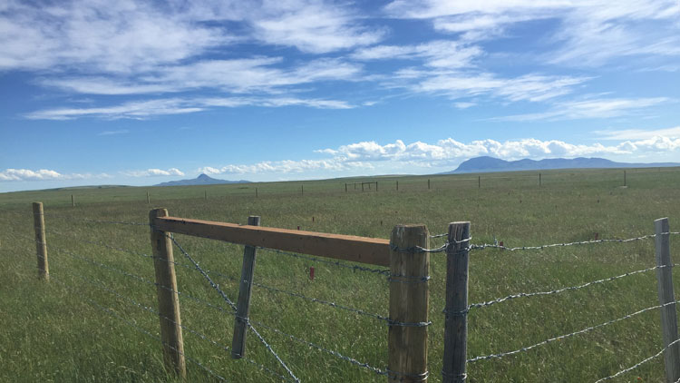

*Rangeland Sustainability Program project area near Milk River, focusing on downy brome control.*

“Our rangelands are an important natural asset, providing food for livestock, supporting rural communities and helping conserve Alberta’s biodiversity. Managing them responsibly benefits all Albertans and expands recreational access, which is why we’re investing in the Rangeland Sustainability Program and supporting multiple uses on these incredible landscapes.”

*Todd Loewen, Minister of Forestry and Parks*

“Healthy rangelands are the foundation of a strong agricultural sector. This investment supports the farmers and ranchers who rely on these landscapes to raise livestock and sustain their operations, while also promoting long-term environmental stewardship. By working with Indigenous groups, researchers and local communities, we’re helping to ensure Alberta’s rangelands remain productive, resilient and ecologically rich for generations to come.”

*RJ Sigurdson, Minister of Agriculture and Irrigation*

Alberta’s rangelands are important working landscapes supporting food production, clean air, fresh water, timber harvesting, wildlife habitat preservation, and forage for livestock, while contributing to the lives and livelihoods of farmers and ranchers.

The Rangeland Sustainability Program is funded by a portion of rental fees collected from grazing disposition holders located on Crown land, which is then reinvested into projects that support responsible stewardship across Alberta’s vast rangelands.

“The RSP grant provides essential support to SASCI’s Grassland Restoration Forum (GRF), helping advance the conservation and restoration of Alberta’s native grasslands. With this funding, GRF delivers outreach, training and resources to improve reclamation practices and support those working in rangeland management.”

*Jane Lancaster, Southwest Alberta Sustainable Community Initiative*

“Through the Rangeland Sustainability Program, PCBFA is exploring the integrated management of trees, forages and livestock in silvopastoral systems. These systems have the potential to provide improvements in multiple areas, including soil fertility and conservation, wildlife habitat, forage quality, animal production, income diversity and greenhouse gas mitigation.”

*Liisa Jeffrey, executive director, Peace Country Beef & Forage Association*

**2024-25 funding recipients**

* Alberta Native Bee Council
* Blood Tribe Land Management
* Peace County Beef and Forage Association
* Southwest Alberta Sustainable Community Initiative
* University of Alberta — Dr. Edward Bork
* University of Alberta — Dr. James Cahill
* Western Stock Growers Association

Applications for Rangeland Sustainability Program funding are now open for the 2025-26 fiscal year. Applicants will be considered based on knowledge and understanding of rangeland management. Applications are open until Sept. 17.

**Quick facts**

* In 2024-25, Forestry and Parks allocated more than $1.3 million in funding for the Rangeland Sustainability Program.
* Annual funding has increased each fiscal year since inception from $43,000 (2020-21) to $1.33 million (2024-25), due to increases in cattle prices and a phase-in of the new grazing disposition rental rates.

**Related information**

* [Rangeland Sustainability Program](https://www.alberta.ca/rangeland-sustainability-program)

**Media inquiries**

[**Neil Singh**](mailto:Neil.Singh@gov.ab.ca)

780-644-7353  
Press Secretary, Forestry and Parks