
News release

The results are in: new plate revealed
November 18, 2025 Media inquiries
Albertans have spoken and for the first time in more than 40 years, a new, beautiful, refreshed licence plate with the “Strong and Free” motto will hit the road in 2026.
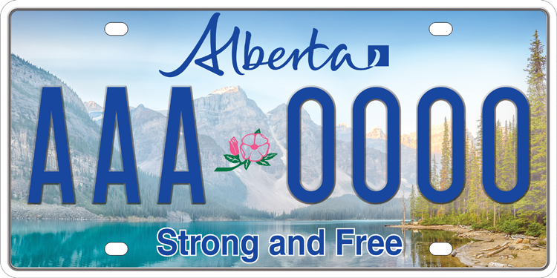
Albertans have chosen beautiful Moraine Lake in Banff National Park as the new design for the province’s licence plate.
After three rounds of voting and more than 240,000 votes cast, Albertans have spoken. The iconic Moraine Lake in Banff National Park will be featured on the province’s new licence plate.
Available in mid-2026, echoing the “Strong and Free” motto of our province, the plate reflects Alberta’s bold identity, economic strength and deep-rooted provincial pride. The motto’s inclusion on the licence plates will also serve as a nod to Canada’s national anthem and Alberta’s position as a strong and sovereign province within a united Canada.
“Albertans know who we are and what we stand for: we are strong, free, resilient and united by the natural beauty that defines our home. Moraine Lake is recognized around the world, and the fact that Albertans chose it makes this new plate deeply meaningful. Thank you to the Albertans who cast more than 240,000 votes and helped choose a design that showcases Alberta’s natural beauty and will stand as a proud symbol of our province for years to come.”
Danielle Smith, Premier
Moraine Lake is one of Alberta’s most iconic destinations, making it fitting that it be on the province’s licence plates for motorists around the country to see. The licence plate depicts the breathtaking panoramic view of Moraine Lake that perfectly displays the province’s beautiful Rocky Mountains, which attract visitors from around the world to Alberta.
“Having the iconic Moraine Lake on our licence plates is something we can all be proud to show off. Thank you to every Albertan who cast their vote in our tournament. Because of you, the beauty and strong and free spirit of our province will be on display for motorists across the country.”
Dale Nally, Minister of Service Alberta and Red Tape Reduction
If an Albertan wants to replace their current plate for the new licence plate once it is released, they can voluntarily pay a $28 fee. Alternatively, Albertans could obtain a new plate on their vehicle registration renewal date at no additional cost. Motorists may also continue using the previous licence plate once the new licence plate is brought onboard, provided it is still in good condition.

Quick facts
- Alberta’s current licence plate was designed in 1984.
- In 2021, Alberta began a transition from painted to reflective plates with the same design.
- The new design incorporates reflective technology to improve readability for law enforcement and automated systems in low-light conditions, and to meet international standards for visibility, legibility and counterfeit resistance.

Related information
- Alberta pick a plate
- Licence plates
- Motor vehicle information
- Motor vehicles – eServices

Media inquiries

Kevin Lee
587-785-4366
Press Secretary, Service Alberta and Red Tape Reduction

