**News** release

**Improving private land conservation**

July 15, 2025 Media inquiries

Alberta’s government is investing $10 million and making it easier for landowners to conserve natural areas while keeping people working.

Alberta’s government is launching two new and improved private land conservation programs to better meet the needs of landowners, conserve more land and prioritize the needs of Albertans. With $10 million in funding now available, the enhanced Private Land Conservation Program and the new Ecosystem Services Grant Program will better protect natural areas across the province while still enabling landowners to use their land for farming, ranching and other work.

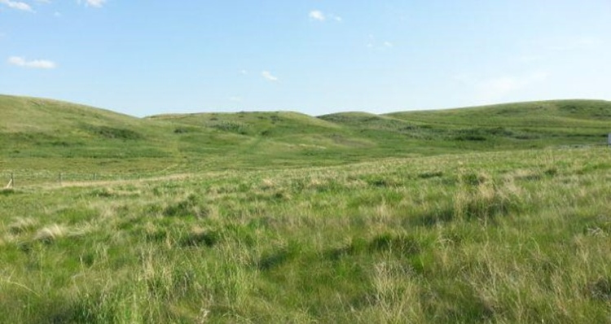

*A property in the Rosebud River Conservation Area, northeast of Calgary (Credit: Western Sky Land Trust Society)*

Private landowners across Alberta strongly support conservation, with more than 142,000 acres conserved since 2019. However, decisions made today may not make sense 50 years from now, and many Alberta landowners have asked for more flexible conservation programs to help them protect the land while making a living.

“Landowners have been asking for a program that supports conservation while still letting them safely and sustainably use their lands. These new and improved programs will deliver greater environmental impact per dollar by aligning conservation outcomes with landowners’ needs and on-the-ground realities.”

*Rebecca Schulz, Minister of Environment and Protected Areas*

**Improved program, new name**

Under the newly created Private Land Conservation Program, formerly the Land Trust Grant Program, funding will be distributed to Alberta-based land trusts only, ensuring money meant for conservation in Alberta stays in the province and benefits Albertans. New term conservation easements will also ensure maximum flexibility for future landowners while still protecting the environment. Term conservation easements, which can last up to 50 years, offer an effective way to conserve land for a generation while allowing future flexibility for landowners and communities.

“The Alberta Conservation Association is excited to see the launch of the enhanced Private Land Conservation Program. It provides us with new and innovative tools to support private landowners in Alberta’s ongoing, collaborative efforts to conserve our rich natural heritage for future generations.”

*Lance Engley, special projects manager, Alberta Conservation Association*

**Ecosystem conservation support**

The new Ecosystem Services Grant Program helps landowners cover the costs of maintaining conservation lands that benefit all Albertans. For example, grasslands, riparian areas and wetlands provide habitat and biodiversity while naturally absorbing rainfall and reduce runoff. By conserving these landscapes, vital ecosystem services that support Albertans are protected.

"Alberta Beef Producers is encouraged to see the government recognizing the value of ecological goods and services and taking steps to support working landscapes. Canada loses approximately 148,000 acres of grasslands each year, and programs like this can help keep ranchers, the stewards of these native ecosystems, on the land, maintaining healthy habitat and supporting species at risk for generations to come."

*Doug Roxburgh, chair, Alberta Beef Producers*

Applications are being accepted for both the Private Land Conservation Program and Ecosystem Services Grant Program until Oct. 1, 2025. Details on how to apply and eligibility are available on Alberta.ca.

**Quick facts**

* Funding for private land conservation programs comes from the Land Stewardship Fund, which generates funds from the sale of public land.
* Budget 2025-26 allocated $10 million from the Land Stewardship Fund for this fiscal year.
* Since 2019, more than 142,000 acres of private land has been conserved.

**Related information**

* [Conservation on private land](https://www.alberta.ca/conservation-on-private-land)
* [Private Land Conservation Program](https://www.alberta.ca/private-land-conservation-program)
* [Ecosystem Services Grant Program](https://www.alberta.ca/ecosystem-services-grant-program)

**Media inquiries**

[**Kevin Lee**](mailto:kevin.r.lee@gov.ab.ca)

587-785-4366  
Acting Press Secretary, Environment and Protected Areas