**News** release

**Plan an adventure with Alberta’s trail guide**

July 16, 2025 Media inquiries

Alberta’s government is releasing the 2025 Alberta Public Land Trail Guide, which will help Albertans plan their next outdoor adventure on public lands.

The 2025 Alberta Public Land Trail Guide helps outdoor enthusiasts plan ahead for their next outing to explore the province’s great outdoors, connect to the land and try something new this summer. Whether heading out for the day or staying overnight, Alberta’s public lands offer breathtaking outdoor spaces and memories that will last a lifetime.

“Public land use trails are a big part of what makes Alberta special. These trails give visitors a chance to get outside, explore our province’s natural beauty and enjoy everything from hiking to camping. As an avid outdoorsman, I know the value of connecting with nature and enjoying Alberta’s backcountry, and this year’s guide makes it easy for everyone to spend time outdoors.”

*Todd Loewen, Minister of Forestry and Parks*

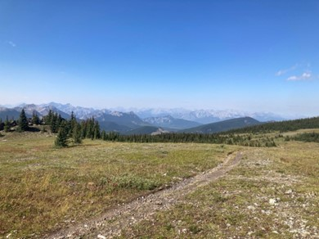

*Public land trail along the eastern slopes of the Rocky Mountains*

Featuring trail-management partners from across the province, the guide helps visitors connect to the outdoors, suggests new recreation activities and provides safety tips and trail etiquette to help everyone enjoy the outdoors safely and responsibly.

“The Government of Alberta’s Trail Guide continues to be a vital tool in promoting safe, sustainable recreation across the province. With so many exceptional trails in our region, this guide plays an important role in helping connect Albertans and visitors to the landscapes we’re proud to help steward.”

*Michelle Swanson, reeve, Clearwater County*

If a multi-day trip is on the agenda, a public lands camping pass is required for camping in busy areas along the eastern slopes. Funds from the pass are reinvested in the region to improve recreation experiences, enhance infrastructure and protect these landscapes for future generations.

From hiking and cycling to off-highway vehicle use, horseback riding, angling, hunting and camping, there’s something for everyone to do on Alberta’s public lands. These outdoor adventures are not only a great way to bring people together and explore the province, but also drive visitors to rural communities, strengthening local economies and supporting local businesses across Alberta.

**Quick facts**

* The Ministry of Forestry and Parks first published the summer trails guide in 2023.
* Albertans spend $2.3 billion on Crown land recreation annually, and another $376 million on recreation equipment and accessories.
* There are about 7,000 kilometres of provincially designated trails in Alberta.

**Related information**

* [2025 Public Land Trail Guide](https://open.alberta.ca/dataset/41efb435-2cbf-4c80-9f0c-15bcb103cdc9/resource/11c0d52d-5751-4613-a5f9-a01f279e4d43/download/fp-albertas-public-land-trail-guide-summer-2025.pdf)
* [Public Lands Camping Pass](https://www.alberta.ca/public-lands-camping-pass)

**Media inquiries**

[**Neil Singh**](mailto:neil.singh@gov.ab.ca)

587-385-9649  
Press Secretary, Forestry and Parks