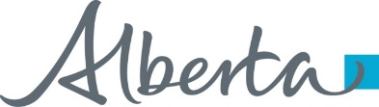**News** release

**Working together to strengthen legal aid**

July 17, 2025 Media inquiries

A new governance agreement brings long-term sustainability for legal aid services in Alberta.

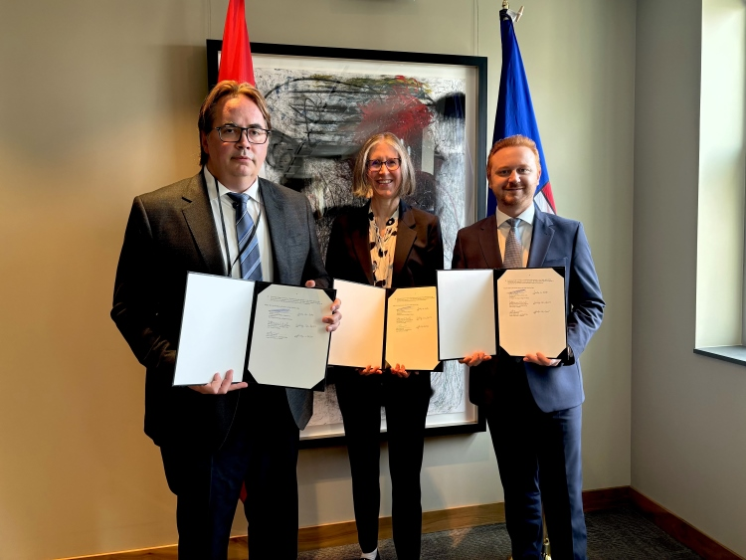

*Ryan Callioux, KC, board chair, Legal Aid Alberta; Stacy Petriuk, KC, president, Law Society of Alberta; Mickey Amery, KC, Minister of Justice and Attorney General.*

Through a collaborative process with Legal Aid Alberta and the Law Society of Alberta, an updated five-year governance agreement for legal aid services has been signed. Alberta’s government is committed to ensuring Albertans have access to an effective and affordable justice system. This includes making sure vulnerable and low-income Albertans can secure timely legal aid services now and for years to come.

“This agreement reflects a shared commitment to maintain an independent, stable and sustainable legal aid system in Alberta – one that can adapt to future challenges while continuing to serve those facing financial barriers to access legal support. Alberta’s government remains committed to ensuring access to justice for all Albertans.”

*Mickey Amery, KC, Minister of Justice and Attorney General*

The new governance agreement came into effect on July 16 and will continue until July 2030. The new agreement reinforces the importance of Legal Aid Alberta’s role as an independent, non-profit society and affirms the province’s commitment to the current model that balances accountability, flexibility and responsiveness.

Key highlights of the governance agreement include:

* A dispute resolution mechanism that provides a structured and impartial way to address disagreements and aims to help resolve disputes constructively and quickly.
* Additional oversight and renewal terms along with provisions for ongoing consultations between the Government of Alberta, Legal Aid Alberta and the Law Society of Alberta.
* A new directive provision enabling Alberta’s government to have the information needed to secure the long-term sustainability of legal aid services in the province.

“This new governance agreement underscores and safeguards the principle of independence in the delivery of legal aid services in this province. It reaffirms Legal Aid Alberta’s role as an essential partner within the justice system and ensures services remain responsive to community needs for years to come. With this agreement in place, we turn our full attention to the work that matters most: delivering legal services to Albertans who need us.”

*Ryan Callioux, KC, board chair, Legal Aid Alberta*

In October 2024, Alberta’s government launched a comprehensive review of the legal aid delivery model and engaged with justice system partners across Alberta. Through this review, Alberta’s government worked with Legal Aid Alberta and the Law Society of Alberta to strengthen the current model, so it remains responsive to the needs of Albertans. With this new agreement and secured funding in place, Albertans can be confident in the stable and strengthened future of Legal Aid Alberta and access to justice in the province.

“This is an important day for access to justice in Alberta and we are pleased to have reached this milestone, alongside our cosigners. The amendments to the Legal Aid Governance Agreement provide Legal Aid Alberta with greater certainty on its long-term sustainability while at the same time strongly positioning Legal Aid Alberta to continue to positively impact the justice system through its work. The Law Society is committed to ongoing collaboration with all parties to support the continued delivery of critical legal services for vulnerable Albertans in the years to come.”

*Stacy Petriuk, KC, president, Law Society of Alberta*

**Quick facts**

* Alberta’s government contributed $88.1 million in 2025-26 to Legal Aid Alberta.
* In the last year, Legal Aid Alberta supported Albertans in more than 319,000 legal matters, including 45,000 full representation certificates.
* The Government of Alberta, the Alberta Law Foundation and the federal government fund legal aid.

**Related information**

* [Governance agreement respecting Legal Aid (2025)](https://open.alberta.ca/publications/governance-agreement-respecting-legal-aid)
* [New legal aid agreement reached (Sept. 4, 2024)](https://www.alberta.ca/release.cfm?xID=90934676424E8-BDF7-440C-AF5126EF6734B2F8)
* [Making legal aid more accessible to Albertans(Feb. 14, 2024)](https://www.alberta.ca/release.cfm?xID=897439A4E9855-9C69-7B1F-78206D536F3D464C)

**Media inquiries**

[**Heather Jenkins**](mailto:Heather.Jenkins@gov.ab.ca)

780-245-0421  
Press Secretary, Justice